# **Converting the Properties File into a JSON Payload**

Step 1: Create a new Integration Project, select the ESB, Composite Exporter, Registry Resources and Create a Project.

(To Create an Integration Project, refer the Basic Project Creation Document)

Let us assume the Property File Contains the Values as Follows

Step 2: Click on the Registry Resource and select the new Registry resource.

Step 3: Click on Import from file and click on next.

Step 4: Click on browse from file and select the properties file in your local system.

Step 5: Select the registry as conf and give the registry path then click on Finish.

Now you can see the file in your registry.

Step 6: Right click on the Project and select new and then Select the Mediator Project.

Step 7: Click on the Create New Mediator and then click on Next.

Step 8: Give a name to the Project and specify the Class Name along with its package name then click on Finish.

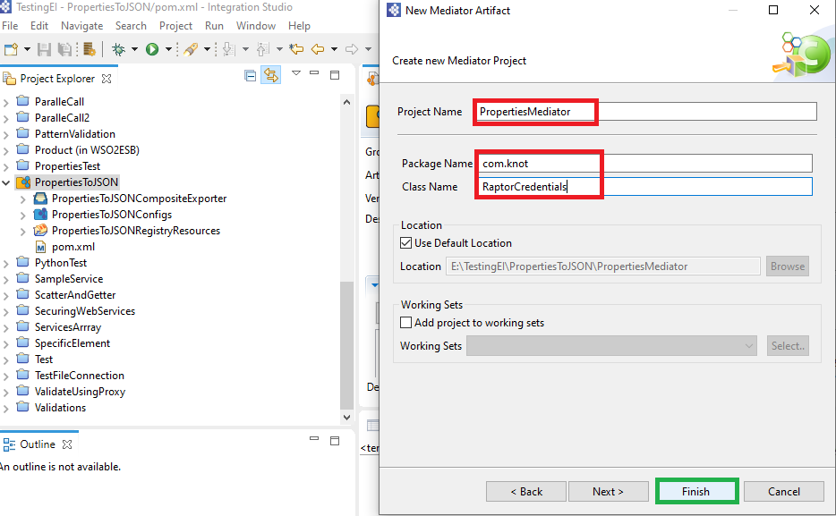

Step 9: The Class is created, and we have to add a additional jar file for JSONObject Class.

Download the Jar file from :<http://www.java2s.com/Code/Jar/j/Downloadjavajsonjar.htm>

Step 10: Right click on the Class and select the Configure the Build Path.

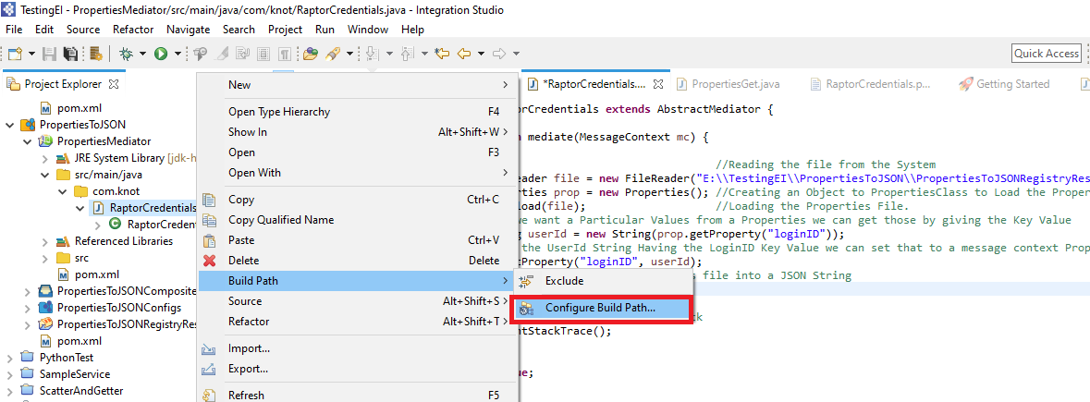

Step 11: Click on Libraries and select the Add External JARs and select the Jar File where you downloaded, then click on Apply and Close.

Step 12: Implement your Java Code and Save the Class.

Step 13: Right click on your mediation project, click on Export.

Step 14: Select the Java Jar File and click on Next.

Step 15: Select all the related files and select a destination to export the JAR and click on Finish.

Step 16: Now go to the API and add the Class mediator and give the Class Name completely along with the package.

Step 17: Add a Payload mediator and set the property as an argument and add the respond mediator.

Ex: Sample Source file of API

Step 18: Click on the Server Configuration of Micro Integrator.

Step 19: Click on the plus icon and add the JAR file and save.

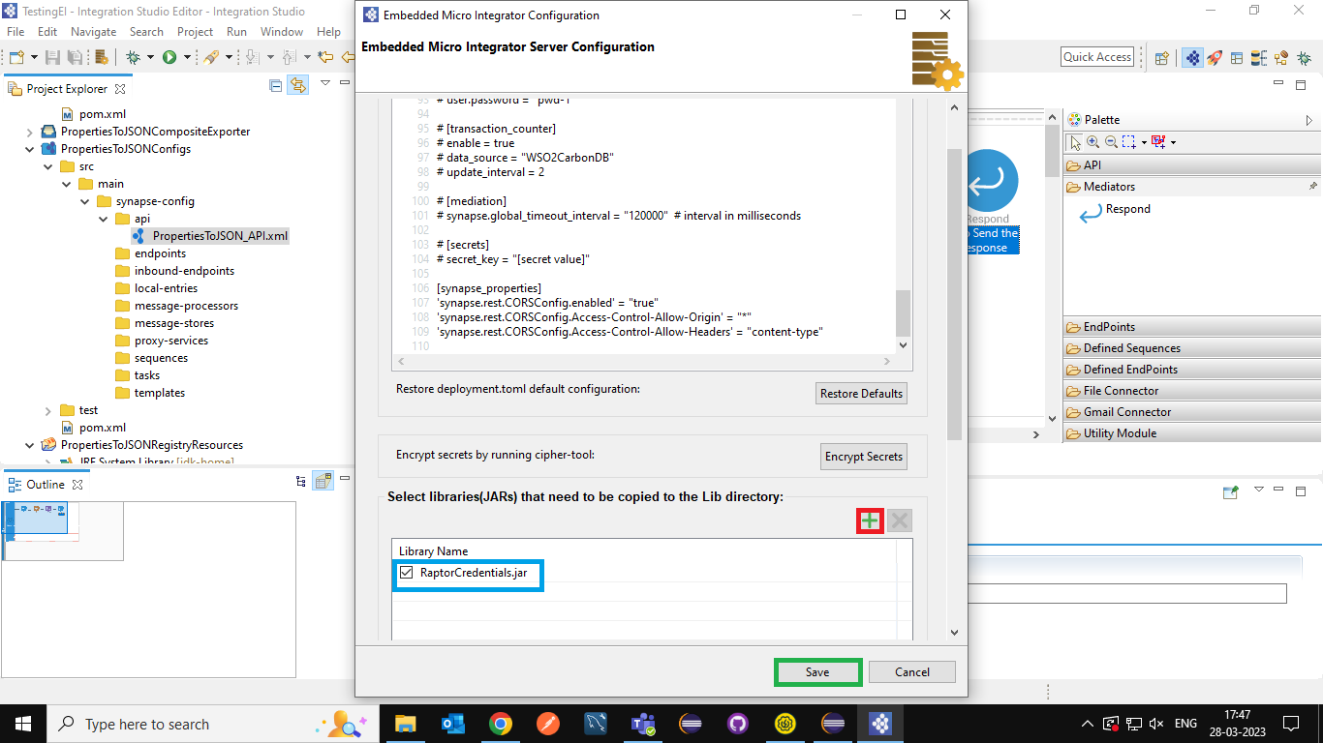

Step 20: Add the ESB Configs and Registry Resource to the CAR file and Save.

Step 21: Right click on the composite exporter and click on Export the Artifacts and Run.

Step 22: Copy the URL and execute it on Postman you can see the Properties are Converted into JSON Key Value Pairs in the Response.

